**Experiment no. 02**

* 1. **Experiment Name**

Experimental study of amplitude modulation and demodulation

* 1. **Objectives**
* To combine message and carrier frequencies, send the signal, receive the same signal, and separate the message signal
* To get acquainted with Amplitude modulation and demodulation techniques
* To carry out amplitude modulation and demodulation functions for under, perfect, and over modulation conditions
  1. **Theory**

Amplitude modulation, or AM for short, is one of the oldest modulation technologies used in radio transmission. Amplitude modulation is a modulation technique utilized in many areas of communication engineering, most notably in the transmission of messages over radio waves.

A message transmission may contain an audio signal or a speech signal. In amplitude modulation, the modulating voltage, whose frequency is typically lower than that of the carrier, changes the amplitude of a carrier signal. The modulation index is the ratio of the magnitude of the message voltage to the magnitude of the carrier voltage. The types of AM are:

* Double sideband-suppressed carrier modulation (DSB-SC)
* Single Sideband Modulation (SSB)
* Vestigial Sideband Modulation (VSB)

Let the modulating voltage & carrier voltage **𝑣𝑚**, **𝑣c** and, respectively, be represented by

**𝑣c = 𝑉𝐶 𝑠𝑖𝑛**(**𝑤𝑐𝑡**)

**𝑣𝑚** = **𝑉𝑚𝑠𝑖𝑛**(**𝑤𝑚𝑡**)

The modulation index is,

$$m=\frac{V_{m}}{V_{C}}$$

The modulation index is a number lying between 0 and 1, and it is very often expressed as a percentage and called the percentage modulation. Our purpose is to get 100% modulation i.e., when m=1 The amplitude of the modulated voltage is,

# *A= $V_{C}$ + $v_{m}$ = $V_{C}$*+𝑉𝑚𝑠𝑖𝑛(𝑤𝑚𝑡)= 𝑉𝐶 (1+ ms𝑖𝑛(𝑤𝑚𝑡))

Thus, the instantaneous voltage of the resulting amplitude-modulated wave is,

***v***= ***Vc sin***(**𝑤𝑚𝑡**)+($m$***Vc***/***2***) ***cos*** (**𝑤c *-*** **𝑤𝑚**) ***t- ($m$ Vc/2) cos*** (**𝑤c** + **𝑤𝑚**) ***t***

* 1. **Apparatus**
* Oscilloscope (Model: GWINSTEK GOS 6112, 100MHz)
* Amplitude Modulation Transmitter Kit (FALCON ACL 01)
* Amplitude Modulation Receiver Kit (FALCON ACL 02)
* Jumper Wires
  1. **Block Diagram & Kit**

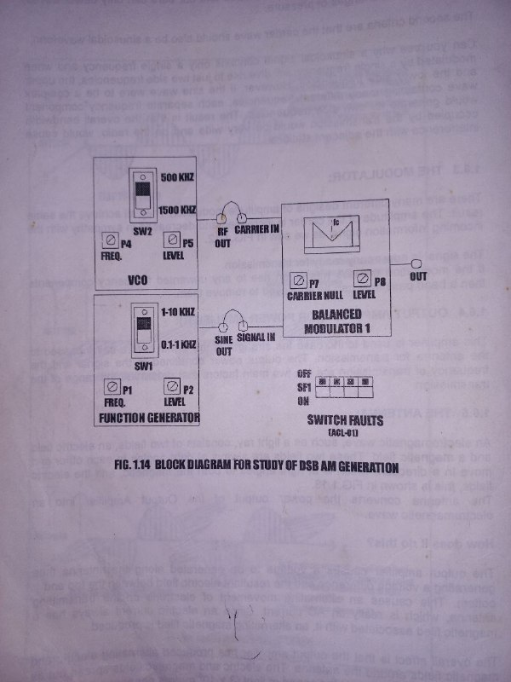

Fig.02.1: Block diagram for amplitude modulation

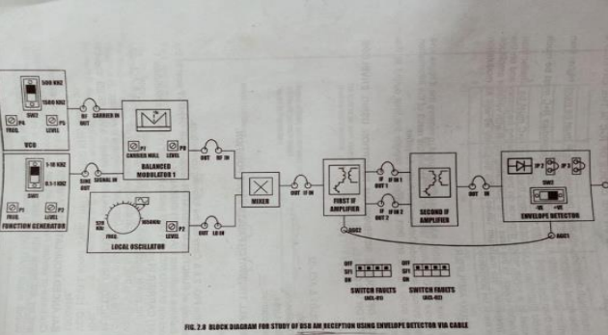

Fig.02.2: Block diagram for amplitude demodulation

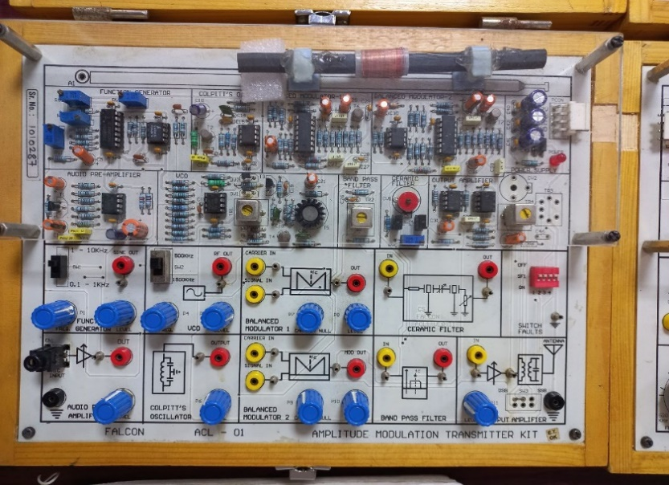 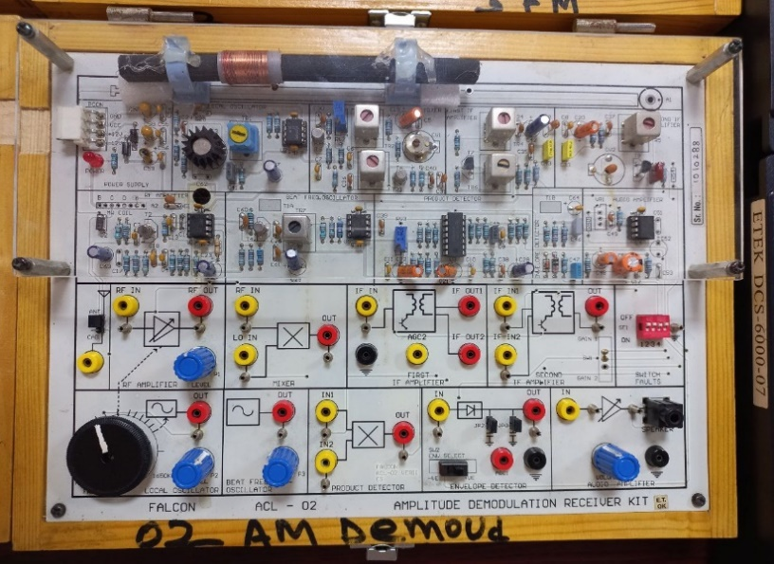

Fig.02.3: Amplitude modulation transmitter kit Fig.02.4: Amplitude demodulation receiver kit

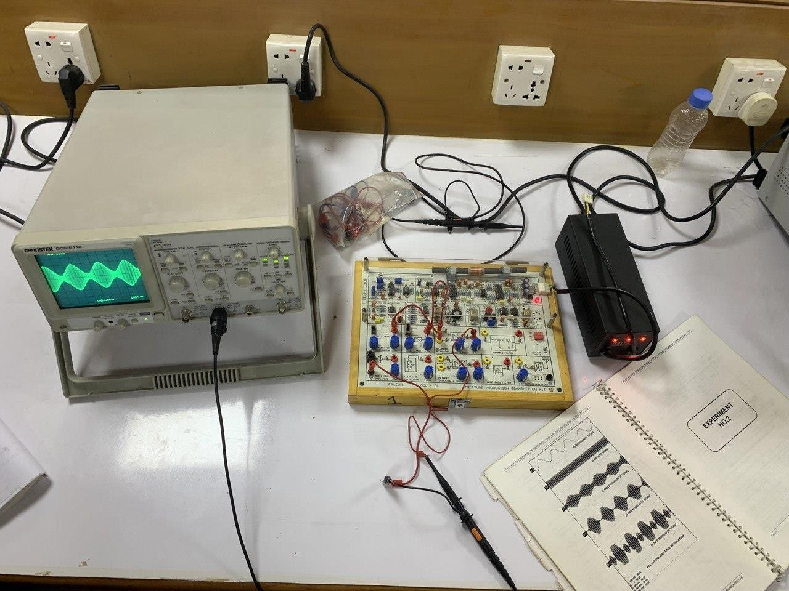

Fig.02.5: Experimental Setup of Amplitude modulation and demodulation Experiment

* 1. **Waveforms**
* **Message Signal Waveform**

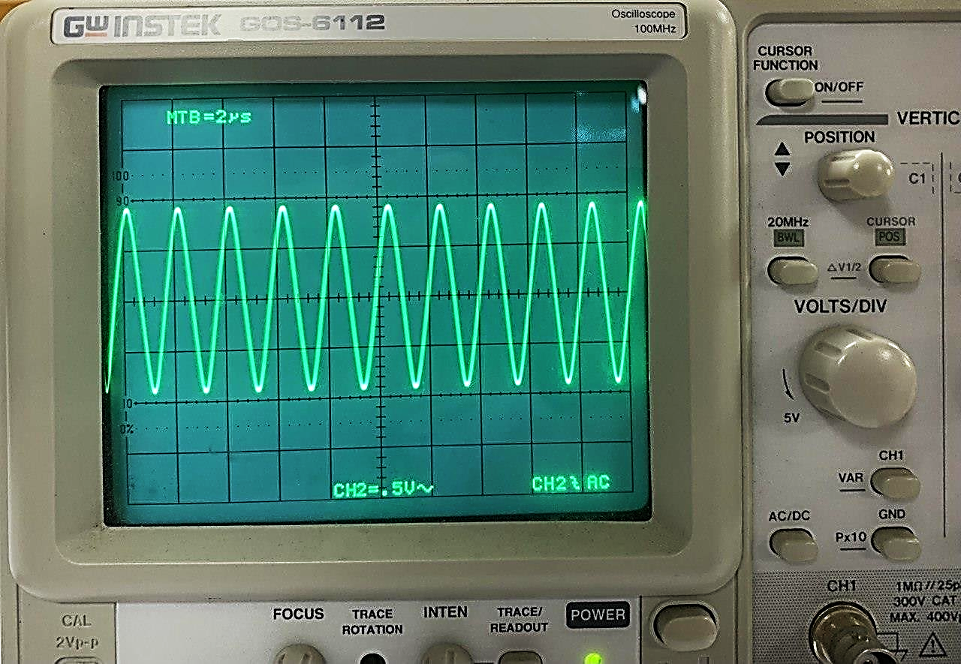

Fig.02.6: Message signal waveform

* **Carrier Signal Waveform**

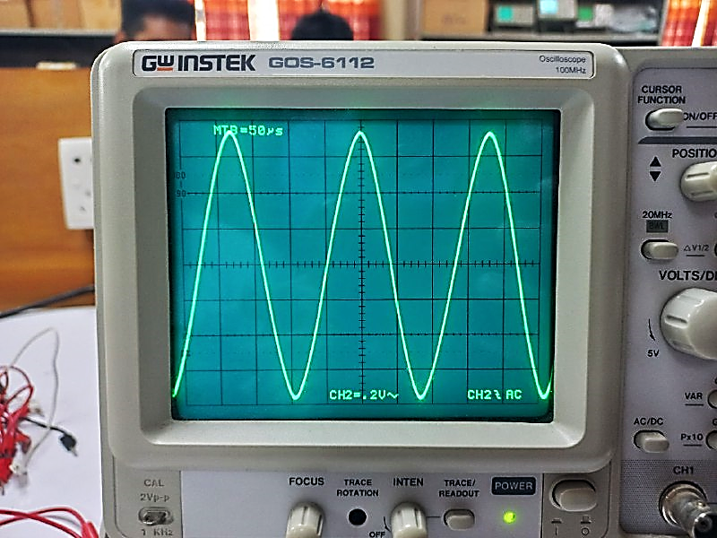

Fig.02.7: Carrier signal waveform

* **Modulated Signal Waveform**

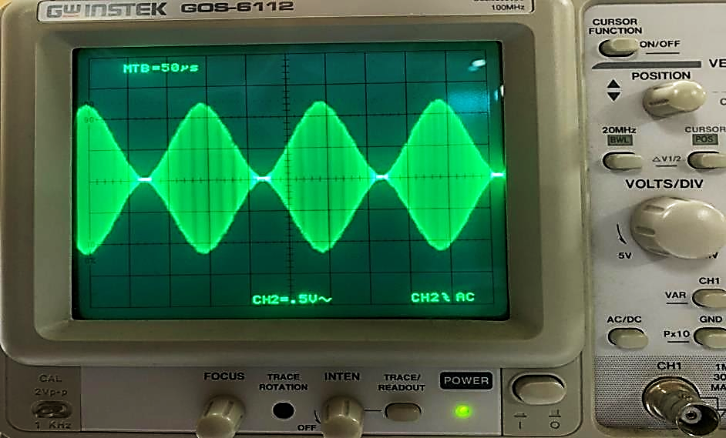

Fig.02.8: Perfectly modulated signal waveform **(m=1)**

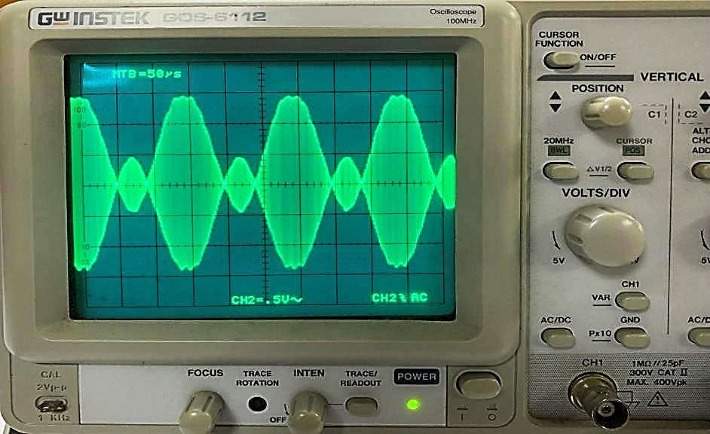

Fig.02.9: Over modulated signal waveform **(m>1)**

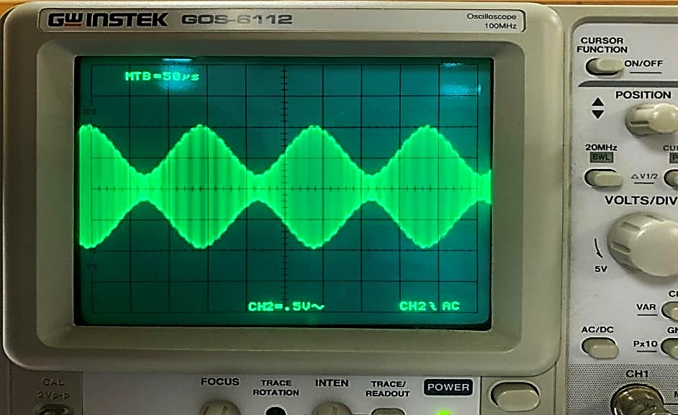

Fig.02.10: Under modulated signal waveform **(m<1)**

* 1. **MATLAB code**

clc;%Clears previous data from command window

clear all; %Removes all variables from the current workspace

m = input('Modulation Index = '); %Modulation index range in from 0 to 1

Am = 5; %Amplitude of the modulating signal

f = 2000; %Frequency

T = 1/f; %Time period of modulating signal

t = 0: T: .2;

fa = 20; %message frequency

ym = Am*sin(2*pi*fa*t);

%ploting modulating signal

subplot(3,1,1)

plot(t,ym)

title('Modulating signal')

%carrier signal

Ac = Am/m; %Carrier Amplitude

fc = fa*10; %Carrier frequency

Tc = 1/fc; %Time period of carrier signal

yc = Ac*sin(2*pi*fc*t);

%ploting carrier signal

subplot(3,1,2)

plot(t,yc)

title('Carrier Signal');

%AM modulation

y = Ac+(1+m*sin(2*pi*fa*t)).*sin(2*pi*fc*t);

%ploting amplitude modulated signal

subplot(3,1,3)

plot(t,y)

title('Amplitude Modulated Signal')

* 1. **MATLAB output waveform**



Fig.02.11: Perfectly modulated signal waveform **(m=1)**



Fig.02.12: Over modulated signal waveform **(m>1)**



Fig.02.13: Under modulated signal waveform **(m<1)**

* 1. **Discussion & Conclusion**

In this experiment, the functions and purposes of amplitude modulated signal through laboratory kits were briefly reviewed. Their operation and working principle were also learnt and discussed.

Theoretically, sending a typical voice signal into open space to the receiving end is impractical because the signal becomes distorted and the power is insufficient to transmit. To transmit the signal, the message signal is mixed with the carrier signal, which is then broadcast into the air for reception by the receiver.

Similarly, the modulated signal is decoded at the receiving end, the carrier is separated, and the true message signal is retrieved.

There was noise in the message signal while receiving it during the experiment. Stray capacitance was developed at the kit and wire junction point, causing the message signal to become slightly distorted.

It was also possible to compare experimentally obtained modulated signal with MATLAB code generated signal. Because the expected consequence was reached, the experiment was declared successful.

* 1. **Reference**
* Book:

Electronic Communication System- George Kennedy

* Links:

https://www.indiamart.com/proddetail/acl-am-amplitude-modulation-transmitter-kit-23707428491.html

https://eletechlabinstrument.com/product/amplitude-modulation-demodulation-trainer-kit/